Object Oriented Programming Lab Project Report
BS Computer Science, Batch 2022F

Fast Food Ordering System

Supervised by:
Supervisor’s Name: Miss Sana Ejaz
Designation:

Submitted by:
S.no | Name | Roll Number
1 | Saad Ali | 2022F-BCS-162
2 | Muhammad Faisal | 2022F-BCS-152
3 | Sami | 2022F-BCS-304



BS in Computer Science
Department of Computer Science & Information Technology
University Road Karachi – 75300
http://www.ssuet.edu.pk

Project Summary/Abstract:

- Brief Introduction:
The online fast food ordering system is a Windows Form application developed using C# for the fast food restaurant "Burger Mania." It provides a convenient and user-friendly platform for customers to browse the menu, add items to the cart, and place orders for delivery. The system also includes a login and signup functionality to ensure secure access and streamline the payment process. Additionally, customers can write reviews about the food and share their experiences.

2. Project Objective:
The objective of this project is to create an efficient online ordering system for Burger Mania that enhances the overall customer experience. The system aims to achieve the following objectives:

- Provide an attractive and engaging user interface that captures the essence of Burger Mania's brand and encourages customers to place orders.
- Enable customers to browse the menu and select items of their choice.
- Implement a secure login and signup mechanism to ensure only registered users can proceed with the payment process.
- Facilitate the management of cart items, allowing users to add, remove quantities before finalizing their order.
- Integrate a secure payment gateway to handle online transactions and ensure the confidentiality of customer payment information.
- Capture and store customer delivery details, including address and contact information, to ensure accurate and timely order delivery.
- Provide customers with order confirmation and estimated delivery time to enhance transparency and customer satisfaction.
- Allow users to write reviews and provide feedback on their dining experience, contributing to the overall reputation of Burger Mania.

3. Project features:
The online fast food ordering system includes the following features:

a) Home Page:
- Display an appealing ad promoting Burger Mania's offerings and encouraging users to place an order.
- Provide a seamless navigation experience to access other sections of the application.

b) Menu:
  - Present the restaurant's menu with a variety of burger options and detailed descriptions.
  - Update the cart summary dynamically to reflect the selected items and their respective prices.

c) Cart Management:
- Display a data grid view on the left side of the menu section, showing the added items' names, prices, and quantities.
- Calculate and display the total price of the items added to the cart.

d) Login and Signup:
- Request user account details, including account number, CVV, expiry date, address, phone number, email, and name.
- Validate and securely store user information for future logins and order processing.

e) Payment and Order Placement:
- Prompt users to sign up or log in before proceeding with the payment.
- Integrate a secure payment gateway for users to enter their payment information.
- Upon successful payment, display an order confirmation message with an estimated delivery time.

f) Review Section:
- Allow users to write reviews and provide feedback about the food and their overall experience.
- Display the reviews to showcase the restaurant's reputation and encourage customer engagement.

These features collectively create a user-friendly and secure online ordering system for Burger Mania, enhancing the overall customer experience and streamlining the food ordering process

In conclusion, the online fast food ordering system developed for Burger Mania provides a convenient platform for customers to order food items, make secure payments, and enjoy a seamless and hassle-free ordering experience. The project successfully achieves its objective of creating an efficient and user-friendly system for online food ordering.

4. Methodology:
UML Case Diagram

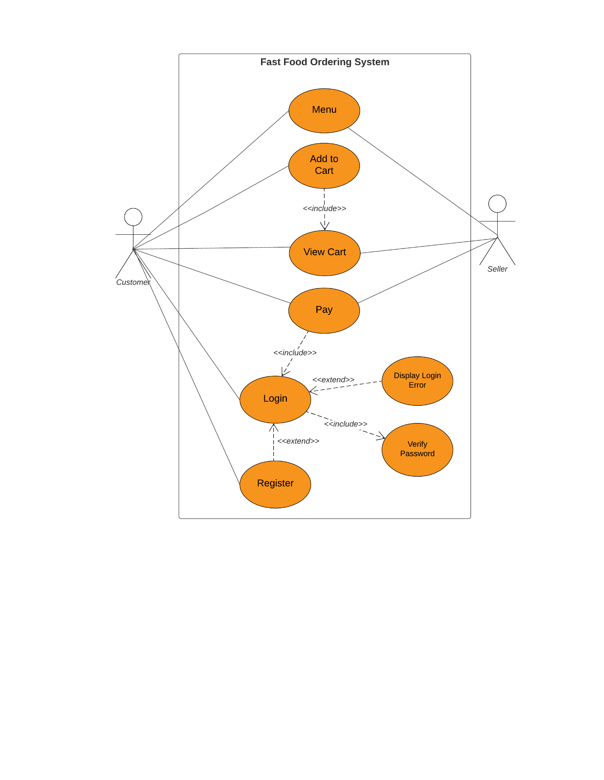

Upon launching the application, the user is presented with the Home Page.
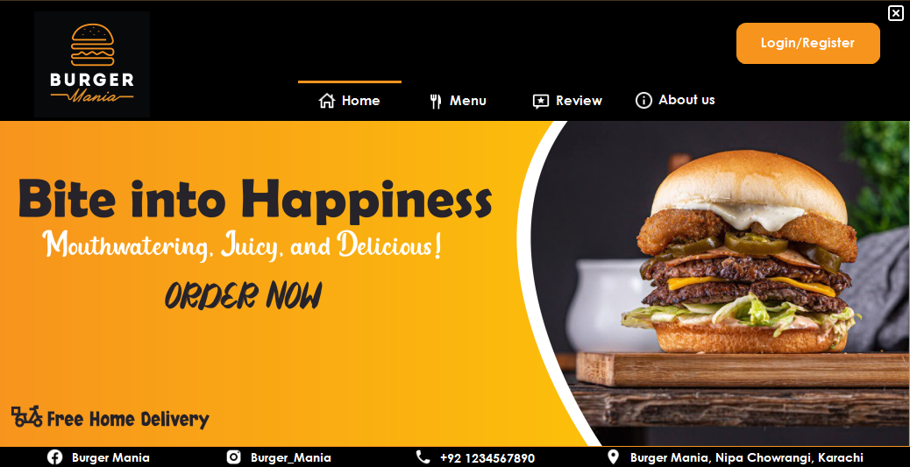

When the user clicks on the menu button, the application displays the menu section.
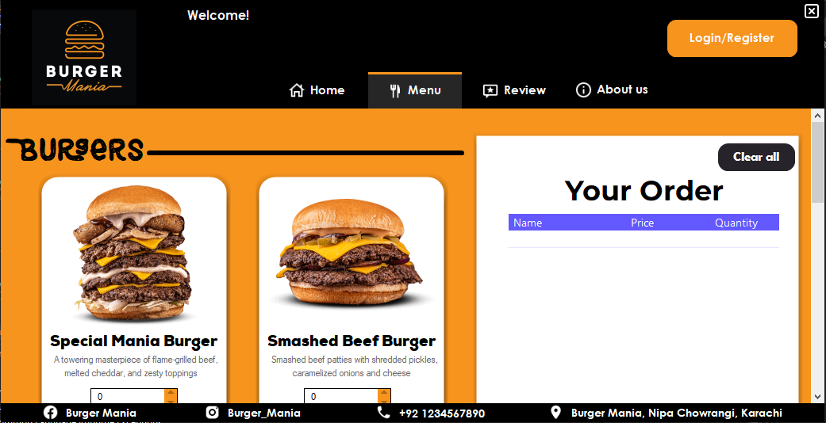

In the menu section the user has the option to select their preferred burger and specify the desired quantity. Upon clicking the "Add To Cart" button, both the chosen burger and the corresponding quantity are included in the cart, displaying the total price.
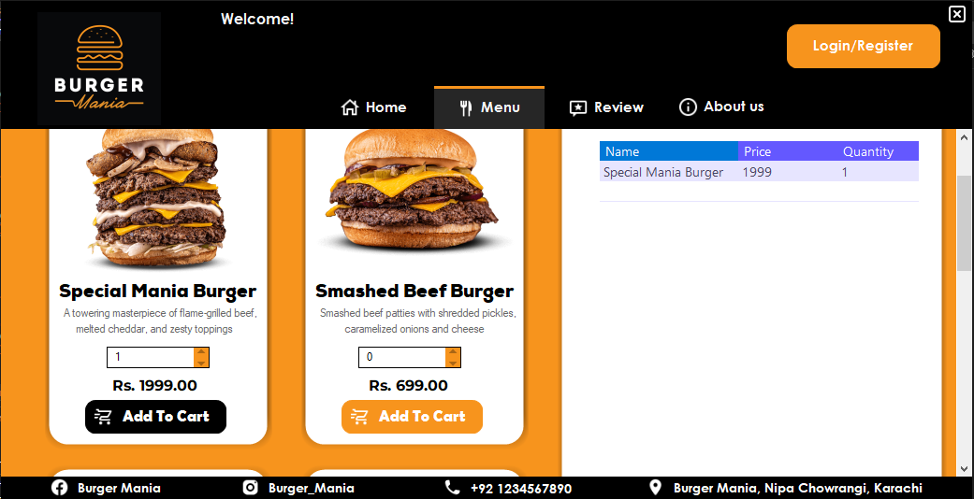

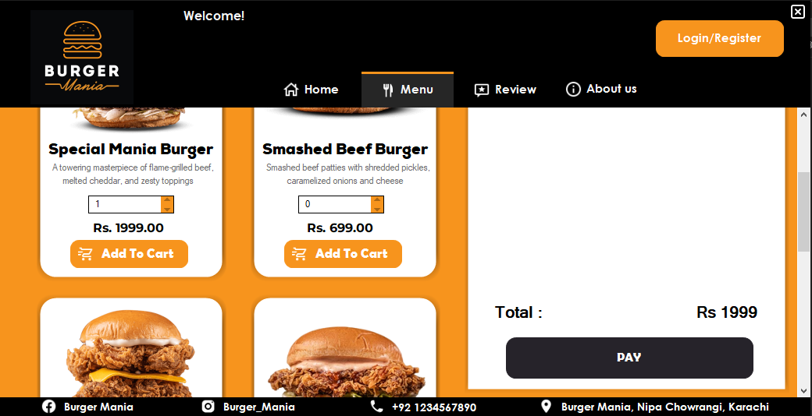

Review Page:

When the user clicks on the "Pay" button without being logged in, a prompt appears requesting the user to log in before proceeding.
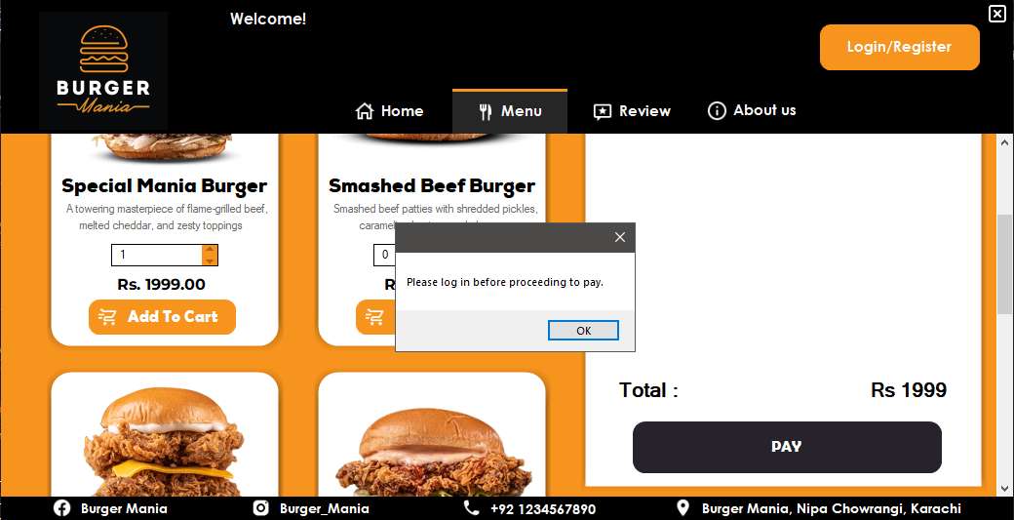

After the user clicks on the "Login/Register" button, they are directed to the login form. If the login attempt is successful, a message will be displayed indicating that the login was successful. However, if the login attempt fails, a message will be shown indicating that the login was unsuccessful.

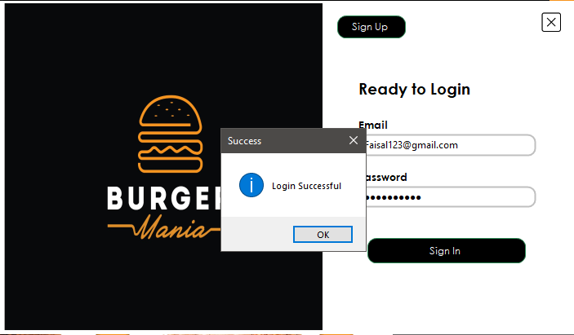

Once the user has successfully logged in, they can proceed with the payment process. Upon clicking the "Pay" button, a message will be displayed on the screen informing the user that they will receive their order within half an hour.
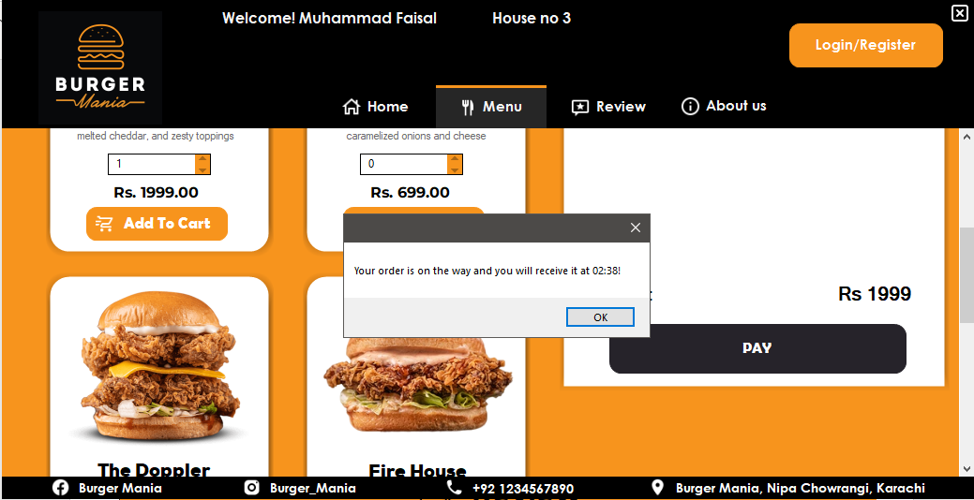
About Us Page:

The user has the option to write a review in the designated review section.
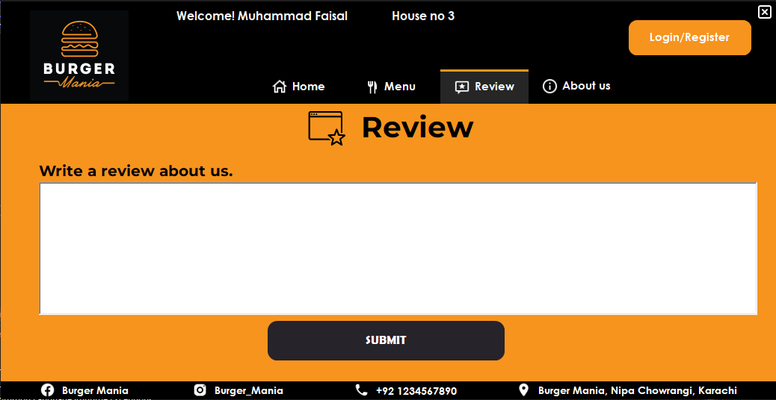

In the "About Us" section, Burger Mania introduces themselves and provides information about their business to the user. They may share details such as their history, mission, values, and commitment to providing quality burgers and exceptional customer service.
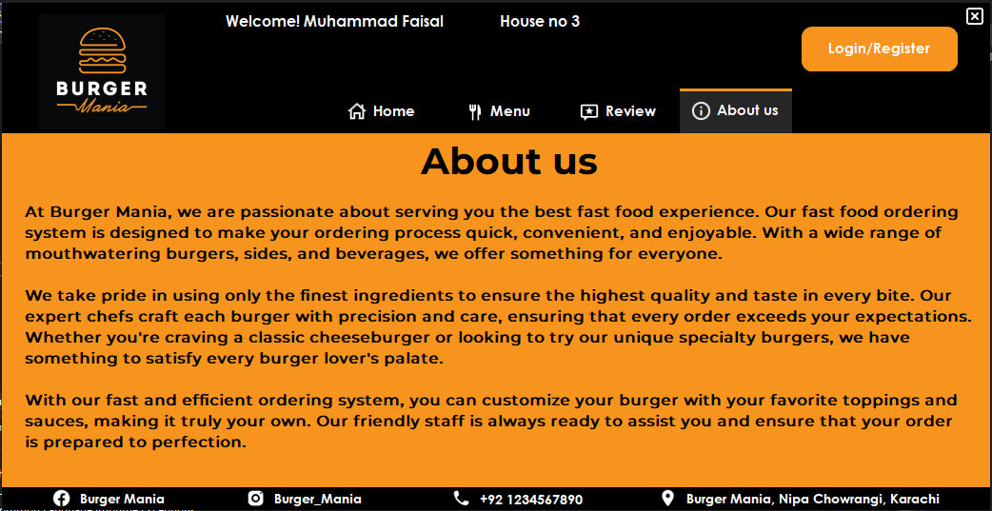

Login Form:

If the user is already signed up or registered, they can proceed to log in using their credentials. However, if they haven't signed up yet, there is an option available for them to register and create a new account.
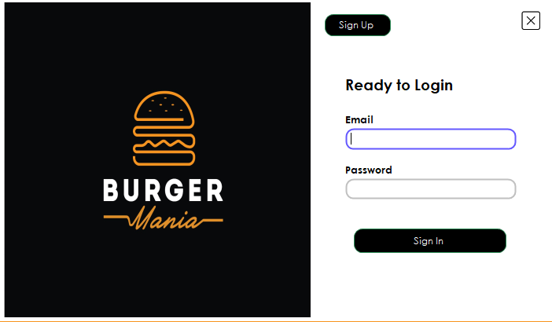

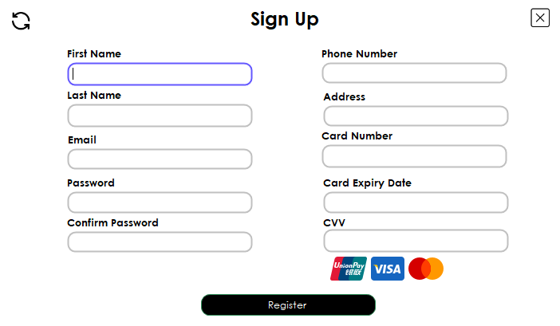

The sign-up form requests the user to provide their personal details for registration.
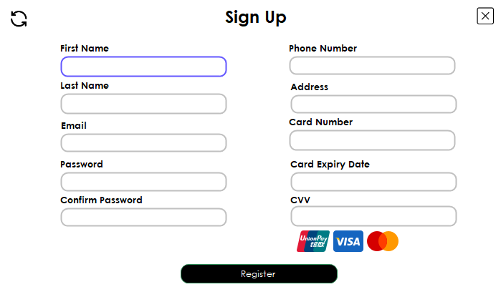

The user can close the application by clicking on the cross button. However, before closing, a confirmation message appears asking, "Are you sure you want to quit?" This allows the user to confirm their intention before exiting the application.

